**MICROSOFT AZURE**

**NAME : ASHWINTH SURIYA V**

**DEPARTMENT: COMPUTER SCIENCE AND BUSINESS SYSTEMS**

**GITHUB LINK: https://github.com/Ashwinthsuriya/azure-fundamentals.git**

**REQUESTING A CLOUD SHELL SUCCEEDED.**

**CONNECTING TERMINAL...**

**Welcome to Azure Cloud Shell**

* az vm create --resource-group "learn-2e807fde-c210-4d1c-b1bb-ba52283b9a45" --name my-vm --public-ip-sku Standard --image Ubuntu2204 --admin-username azureuser --generate-ssh-keys
* az vm extension set --resource-group "learn-2e807fde-c210-4d1c-b1bb-ba52283b9a45" --vm-name my-vm --name customScript --publisher Microsoft.Azure.Extensions --version 2.1 --settings '{"fileUris":["https://raw.githubusercontent.com/MicrosoftDocs/mslearn-welcome-to-azure/master/configure-nginx.sh"]}' --protected-settings '{"commandToExecute": "./configure-nginx.sh"}'
* sudo apt-get update
* ssh azureuser@13.86.212.104
* echo "sudo apt-get update -y
* sudo apt-get install nginx -y
* sudo systemctl start nginx
* sudo systemctl enable nginx" > setup_nginx.sh
* chmod +x setup_nginx.sh
* ./setup_nginx.sh
* echo "<html><body><h2>Welcome to Azure! My name is $(hostname).</h2></body></html>" | sudo tee -a /var/www/html/index.html
* sudo systemctl status nginx
* az vm open-port --resource-group "learn-2e807fde-c210-4d1c-b1bb-ba52283b9a45" --name my-vm --port 80
* az vm list-ip-addresses --resource-group "learn-2e807fde-c210-4d1c-b1bb-ba52283b9a45" --name my-vm --output table
* ssh azureuser@13.86.212.104
* sudo apt-get update
* git clone https://github.com/Ashwinthsuriya/azure-fundamentals.git
* sudo cp -r html/* /var/www/html/
* sudo chown -R www-data:www-data /var/www/html
* sudo chmod -R 755 /var/www/html
* sudo systemctl restart nginx

**EXECUTING COMMANDS IN SANDBOX :**

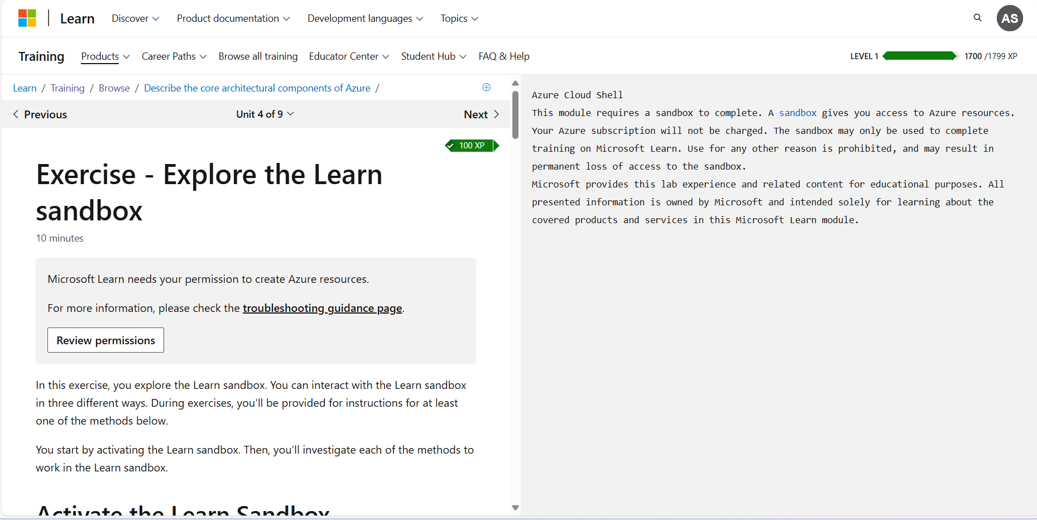

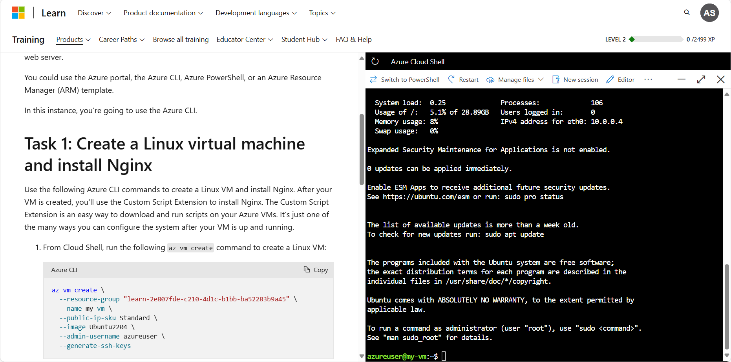

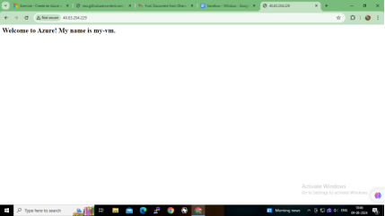 **RUNNING HTML IN BROWSER WITH PUBLIC IP ADDRESS**

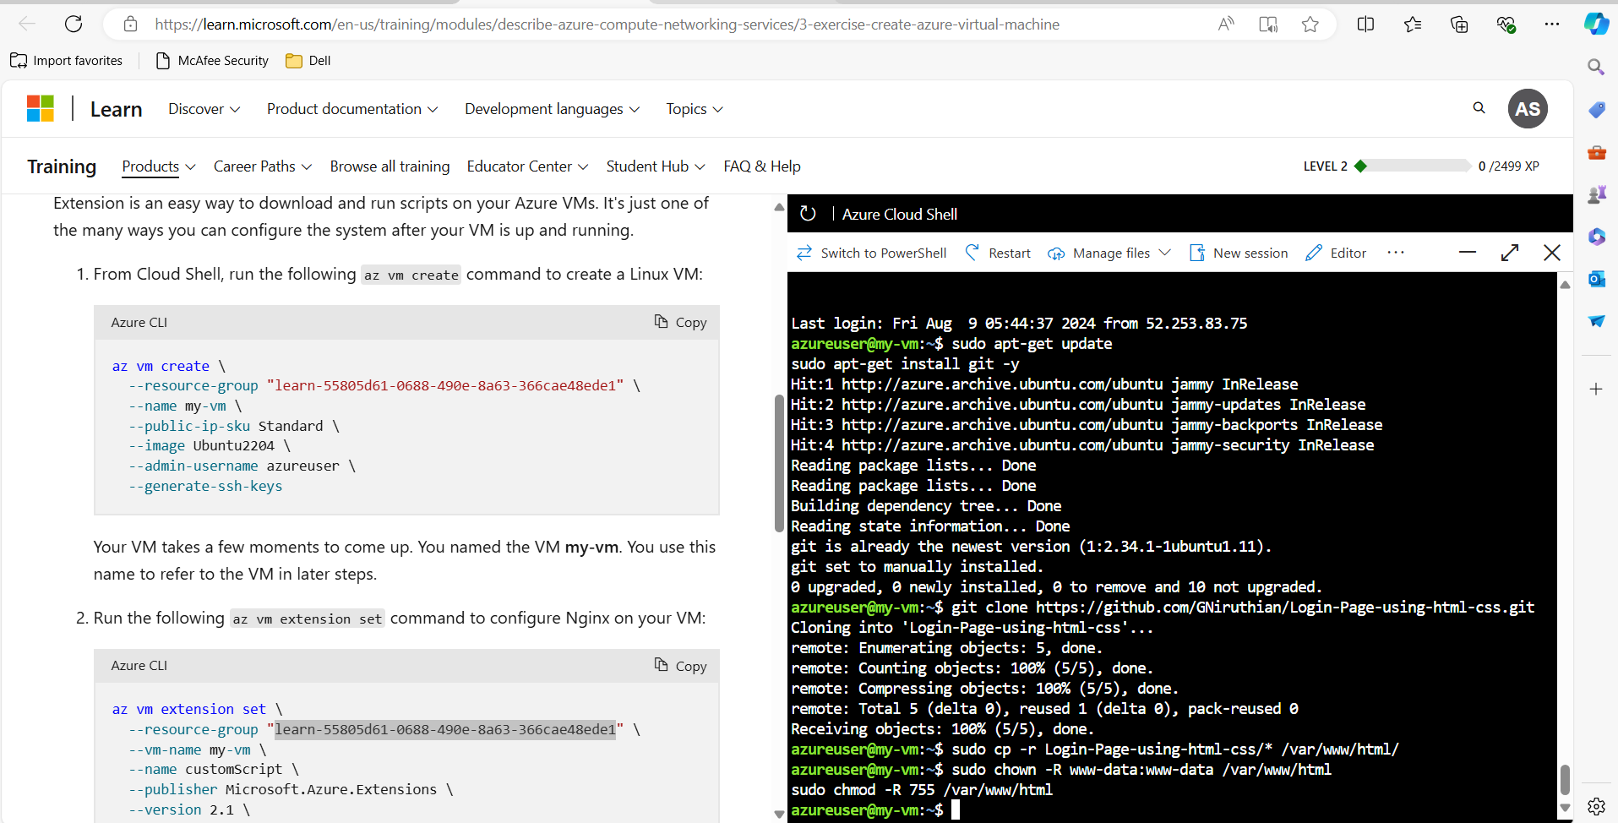**DISPLAYING VIRTUAL MACHINE, PUBLIC AND PRIVATE IP**

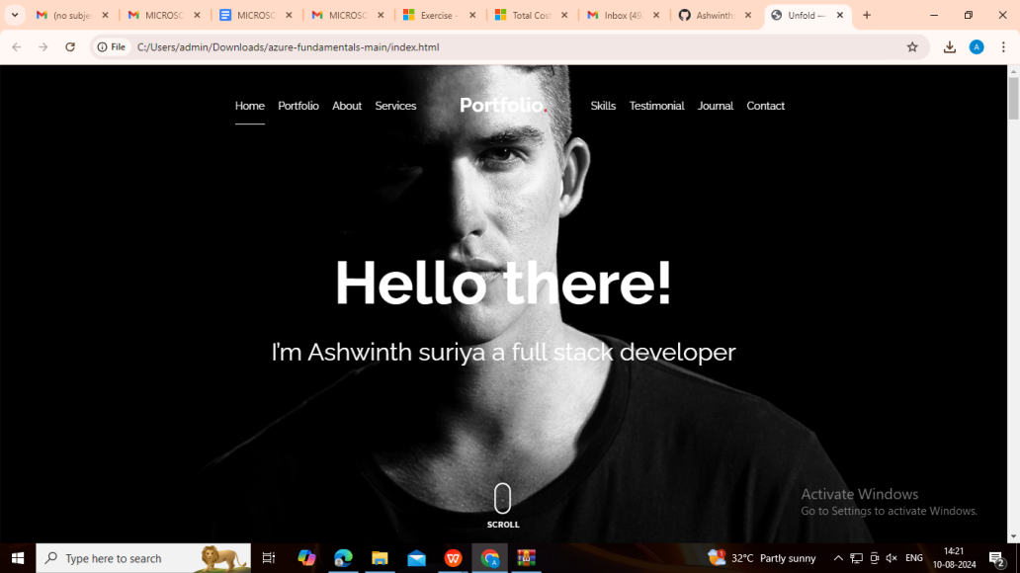**RUNNING PORTFOLIO FROM GITHUB IN THE BROWSER:**